Xray progress 05-01-2026
What is a Generic Test in Xray?
A Generic Test in Xray is a reusable test that uses parameters, variables, or BDD steps so the same test can be executed with different data and in different contexts.
How “Generic” Is Implemented in Xray
Parameterized Tests (Manual / Automated)
Instead of hardcoding values, you use parameters.
Example (Manual Test):
Step: Enter <username>
Step: Enter <password>
Parameters:
username | password
user1 | pass1
user2 | pass2
One test → multiple executions
Very common generic approach

BDD (Gherkin) – Most Common Generic Style
BDD is naturally generic.
Example:
Scenario: User login
Given user is on login page
When user enters "<username>" and "<password>"
Then login result should be "<status>"
This single test works for:
- Valid login
- Invalid login
- Locked user
- Expired password
Reusable BDD Steps (BDD Library)
Xray indexes steps and makes them generic using heuristics.
Example indexed step:
User enters "<value>"
Instead of:
User enters "admin"
User enters "test"
Avoids duplication
Improves automation mapping
Generic Test Linked to Multiple Stories
One test can be:
- Linked to many requirements
- Executed in different Test Plans
- Used across releases
Example:
Test: Verify login functionality
Linked to:
- Story A (Login UI)
- Story B (Security)
- Story C (Session handling)

A generic test case verifies a common functionality that can be reused for multiple scenarios by changing inputs.
Example – Login Page
Specific Test Case
Login with:
Username: user1@gmail.com
Password: Test@123
Expected Result: Login successful
This works for only one data set.
Generic Test Case
Test Case: Verify login functionality with valid credentials
Steps:
1. Open login page
2. Enter valid username
3. Enter valid password
4. Click Login button

Expected Result:
User should be logged in successfully
Can be reused with:
- Different users
- Different environments
- Automation data sets
Generic Test Case vs Specific Test Case
Aspect | Generic Test Case | Specific Test Case
Data | Not hardcoded | Fixed data
Reusability | High | Low
Automation-friendly | Yes | Less
Maintenance | Easy | Hard
Used in | Manual + Automation | Mostly Manual
What are BDD Steps?
BDD steps are structured sentences that describe preconditions, actions, and expected outcomes of a feature.
They follow Gherkin syntax:
- Given → precondition
- When → action
- Then → expected result
- (And / But → continuation)
Example – Login Feature
Given the user is on the login page
When the user enters a valid username and password
And clicks the login button
Then the dashboard should be displayed
Each line above is a BDD step.
Where BDD Steps Exist in Xray
BDD steps are written inside:
- BDD Test issues
- BDD Preconditions
Once saved, Xray:
✔ Indexes them
✔ Stores them in the BDD Library
✔ Makes them reusable
BDD Library (Very Important)
The BDD Library is a centralized place where:
- All indexed BDD steps are stored
- Duplicate steps are avoided
- Steps can be reused across tests
- Automation teams map steps to code
Generic (Parameterized) BDD Steps
BDD steps in Xray can be generic using variables.
Example:
When the user enters "<username>" and "<password>"
Then the login result should be "<status>"
This one step works for:
- Valid login
- Invalid login
- Locked account

Step Index Heuristics (How Xray Makes Steps Generic)
Xray automatically detects:
- Quoted strings → "admin"
- Numbers → 123
- Enums → LEFT, RIGHT
And converts them into:
"<value>" , "<number>" , "<enum>"
This avoids duplicate steps in the library.

Indexing & Re-Indexing of BDD Steps
- Indexing happens when BDD steps are created or updated
- Re-indexing happens when heuristic settings change
- Both run as background tasks

BDD Steps & Automation (Key Point)
BDD steps:
- Do not execute anything by themselves
- Are mapped to automation code (step definitions)
Example mapping in automation:
@When("the user enters {string} and {string}")
Xray stores the steps and results, not the code.

BDD (Behavior-Driven Development) – Overview
BDD is a software development approach where:
- Requirements are written as examples of system behavior
- Business, testers, and developers use a common language
- Tests describe what the system should do, not how it is implemented
BDD improves communication, clarity, and test coverage.

Gherkin Syntax
Gherkin is the language used in BDD to write tests.
- Plain English–like format
- Easy for non-technical stakeholders to understand
- Used by tools like Xray, Cucumber, SpecFlow
Common Gherkin keywords:
- Feature
- Scenario
- Given
- When
- Then
- And, But
Feature
A Feature describes a high-level functionality of the application.
It answers: What capability does the system provide?
Example:
Feature: User Login
As a registered user
I want to log in to the application
So that I can access my dashboard
Scenario
A Scenario is a specific example of how the feature behaves.
It answers: How does this feature work in a particular situation?
Example:
Scenario: Login with valid credentials
Each scenario:
- Is independent
- Has clear steps
- Represents one test case
Given – When – Then
Given (Precondition)
Describes the initial state of the system.
Given the user is on the login page

When (Action)
Describes the action performed by the user/system.
When the user enters valid username and password
Then (Expected Result)
Describes the expected outcome.
Then the user should be redirected to the dashboard

Complete Example:
Feature: User Login

Scenario: Login with valid credentials
Given the user is on the login page
When the user enters valid username and password
And clicks the login button
Then the dashboard should be displayed

What is Indexing in Xray?
Indexing is the process where Xray scans tests (BDD tests and preconditions) and stores their steps in internal libraries so they can be reused, searched, and managed centrally.
What gets indexed?
✔ BDD steps from BDD Tests
✔ BDD steps from Preconditions
✔ Step text and structure
✔ Parameterized versions of steps (based on heuristics)
The indexed data appears in the BDD Library.
When does Xray perform Indexing?
Indexing happens automatically when:
- A BDD Test is created
- A BDD Test is updated
- A BDD Precondition is created or updated
No manual action is required.

What is Re-Indexing in Xray?
Re-indexing means Xray reprocesses all existing BDD steps again and rebuilds the BDD Library.
This is a background task.

When is Re-Indexing triggered?
Re-indexing happens when:
- Step index heuristics are enabled or disabled
- Heuristic rules are changed (quoted strings, numbers, enums)
- You manually request a re-index (admin action)
- Xray configuration affecting BDD steps is updated
This ensures previously created steps follow the new rules.

Why Indexing & Re-Indexing Are Important
Without indexing:
- BDD steps cannot be reused
- Step duplication increases
- Automation mapping becomes messy
Without re-indexing:
- Old steps won’t follow new heuristic rules
- Library becomes inconsistent

Example (Very Clear)
Before Heuristics (No Re-Index)
User selects "red"
User selects "blue"
(NOT) Two separate steps in library

After Enabling Heuristics + Re-Index
User selects "<color>"
✔Single generic step

Performance & Behavior
- Runs in the background
- Does not block users
- Time depends on number of BDD tests
- Large projects may take longer

Permissions (Related)
- Only permitted users/groups can edit BDD Library steps
- Re-indexing respects permission settings
Xray API
Xray API allows you to integrate Xray with external tools such as CI/CD pipelines, automation frameworks, and custom scripts. Using the API, you can create tests, import results, manage executions, and fetch reports programmatically.

What is Xray API?
Xray API is a REST-based interface used to interact with Xray test management data in Jira.
It works with:
- Jira Cloud
- Jira Data Center
(APIs differ slightly between Cloud and DC)
Why Use Xray API?
You use Xray API to:
- Import automation results
- Create/update Tests, Test Executions, Test Plans
- Link tests to requirements
- Fetch coverage & execution status
- Automate test management tasks
Common Xray API Use Cases
1. Import Automation Results (Most Used)
- JUnit
- TestNG
- Cucumber
- NUnit
- Robot Framework
Automatically creates:
- Test issues
- Test Executions
- Test results (PASS / FAIL)
2. Create & Update Tests
- Create manual or BDD (Cucumber) tests
- Update steps, scenarios, or metadata
3. Manage Test Executions
- Create executions
- Update execution status
- Assign environments and versions
4. Traceability & Reporting
- Get requirement coverage
- Fetch test execution status
- Generate reports programmatically
Xray API Types
Xray Cloud API
- Authentication: Client ID & Client Secret (JWT)
- Base API: /api/v2/
- Independent from Jira REST API

Xray Data Center API
- Uses Jira REST authentication
- Endpoints under Jira REST paths
- Tightly coupled with Jira permissions

Authentication (High Level)
Cloud:
- Send Client ID & Client Secret
- Receive JWT token
- Use token for API calls
Data Center:
- Uses Jira user authentication (Basic / Token)

Example Operations (Conceptual)
Action | Purpose
Import test results | Sync automation output
Create Test Execution | Track run
Get Test details | Reporting
Link Test to Story | Traceability
Fetch Test Plan status | Release readiness

What Xray API Does NOT Do
- Write automation code
- Execute tests
- Replace CI/CD tools
- Replace Jira workflows

Where Xray API Fits
Automation Code → CI Tool → Xray API → Jira + Xray
Xray API is the bridge between automation and test management.

What is a Remote Job Trigger?
A remote job trigger is when an action in Jira/Xray calls an external system (like Jenkins, GitHub Actions, GitLab CI) to run automated tests, and then imports the results into Xray.

How It Works
- User action in Jira/Xray
  - Click a button (e.g., Run Tests)
  - Transition a Test Plan / Test Execution
  - Scheduled automation rule
- Jira Automation triggers a remote job
  - Uses Webhook / HTTP request
  - Calls CI tool API (Jenkins, GitHub Actions, etc.)
- CI/CD runs automation
  - Selenium / Cypress / Playwright / API tests
  - Generates result files (JUnit, Cucumber, etc.)
- Results are sent to Xray
  - CI calls Xray API (Import Results)
  - Xray creates/updates Test Execution
  - PASS / FAIL status is recorded

Does Xray Have a Built-in Trigger Button?
No native “Run Automation” engine
Yes, trigger via Jira Automation or Webhooks
Xray relies on:
- Jira Automation
- Webhooks
- Xray REST API
- CI/CD tools
Common Ways to Trigger Remote Jobs
Jira Automation → Webhook (Most Common)
Trigger:
- Issue transitioned (e.g., Test Plan → “Run Automation”)
Action:
- Send HTTP request to CI endpoint
Use case:
- Manual control from Jira

Xray Test Plan / Test Execution Trigger
Trigger:
- Test Execution created
- Test Plan status changed
Action:
- Automation rule fires webhook
Use case:
- Release-based testing

Scheduled Triggers
Trigger:
- Time-based (nightly regression)
Action:
- Call CI job automatically
Use case:
- Nightly / weekly runs

What Xray Manages vs What CI Manages
Area | Xray | CI/CD
Test cases | yes | no
Test executions | yes | no
Result storage | yes | no
Trigger job | no (via Jira) | yes
Execute tests | no | yes
Automation code | no | yes

Typical Tools Used
- CI/CD: Jenkins, GitHub Actions, GitLab CI, Bamboo
- Automation: Selenium, Cypress, Playwright, REST Assured
- Results: JUnit, TestNG, Cucumber, NUnit
- Integration: Xray REST API

Example Real Scenario
“Run regression when Test Plan is ready”
- Trigger: Test Plan → status = Ready for Execution
- Action:
  - Call Jenkins job
  - Jenkins runs tests
  - Jenkins uploads results to Xray
- Outcome:
  - Test Execution updated
  - Coverage visible in Xray
  - Release ticket auto-update

What is Ad-hoc Testing?
Ad-hoc testing is exploratory testing done without formal test steps, focusing on finding defects quickly using tester experience.
How Ad-hoc Testing Is Done in Xray
Xray does not have a separate “Ad-hoc Test” type.
Instead, ad-hoc testing is handled using Xray Test + Test Execution in flexible ways.

Ad-hoc Test Execution (Most Common)
How it works:
- Create a Test Execution
- Add no predefined Tests (or minimal)
- Execute testing manually
- Log results directly:
  - PASS / FAIL
  - Comments
  - Evidence (screenshots, logs)
  - Defects

Sample image of Generic test
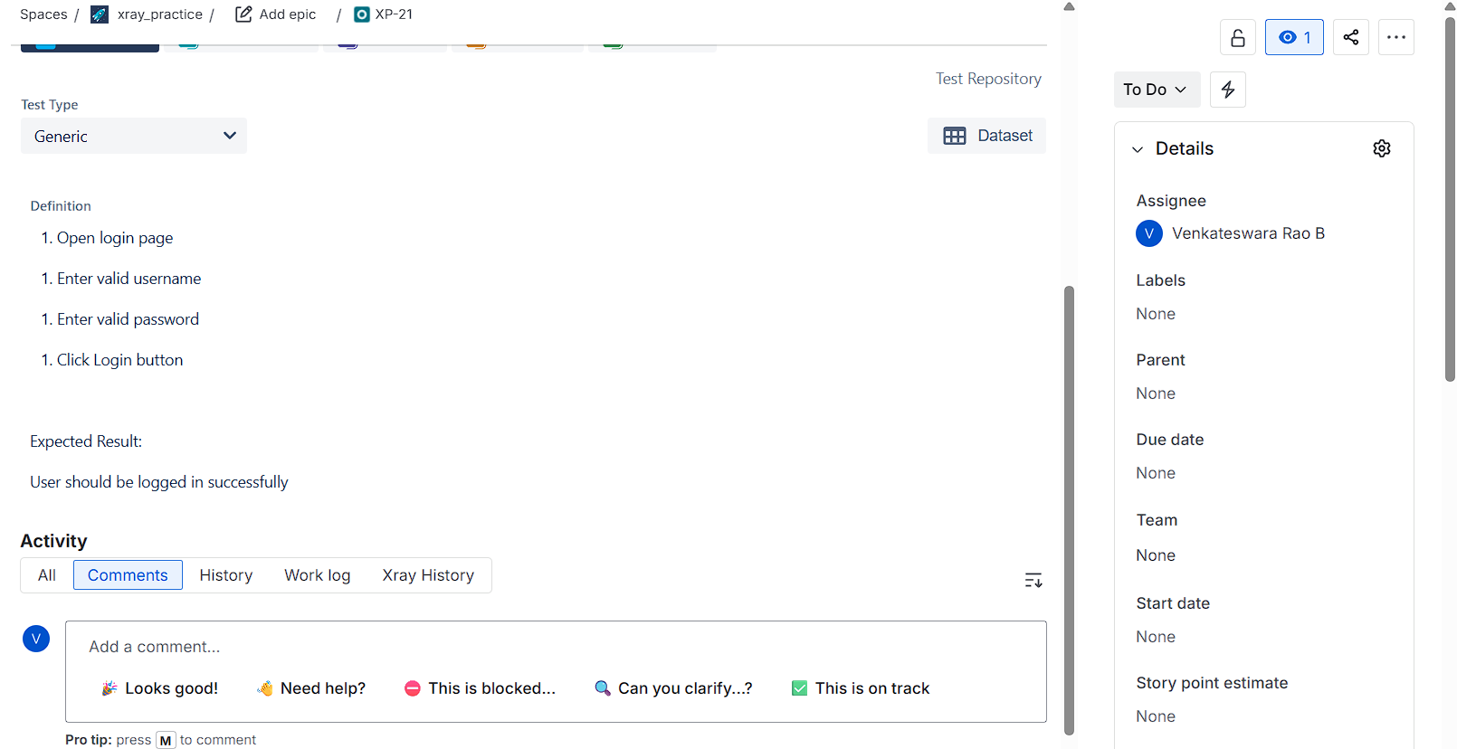

Sample image of cucumber
